Bahria University,

Karachi Campus



COURSE: CSL-220

DATABASE MANAGEMENT SYSTEM LAB

TERM: SPRING 2024, CLASS: BSE- 4(A)

Submitted By:

_____Obaid ur Rehman _______________81918_________ (Name) (Reg. No.)

Submitted To:

Engr. Bushra Fazal/Engr. Noor us Sabah

Signed Remarks: Score:_____

INDEX

|  |  |  |  |  |
| --- | --- | --- | --- | --- |
| SNO | DATE | LAB NO | LAB OBJECTIVE | SIGN |
| 01 | 12/2/2024 | 01 | Querying Database Tables Using Select |  |
|  |  |  |  |  |
|  |  |  |  |  |
|  |  |  |  |  |
|  |  |  |  |  |
|  |  |  |  |  |
|  |  |  |  |  |
|  |  |  |  |  |
|  |  |  |  |  |
|  |  |  |  |  |
|  |  |  |  |  |
|  |  |  |  |  |
|  |  |  |  |  |

Bahria University,

Karachi Campus



LAB EXPERIMENT NO.

**_01_**

LIST OF TASKS

|  |  |
| --- | --- |
| TASK NO | OBJECTIVE |
| 01 | Exercise  a. Get Order id, Product id, Unit price from Order Details.  b. Get the price of an order (by multiplying unit price by quantity).  c. Display all cities that employees belong to but don’t allow repetition.  d. Find complete name of all employees.  e. Display data of all employees those working as Sales Representative.  f. Display complete name of employees those lives in London.  g. Display product name whose unit price are greater than 90$.  h. List the name of all employees whose first name starts with the letter ‘A’.  i. Display names of all employees whose name contain ‘an’.  j. Display the company name where Region is NULL in Customer Table.  k. Write a query to list employees who live in London, Seattle or Redmond  l. Write a query to list employees whose address contains 3 numbers in its start.  m. Write a query to list those employees whose Title of Courtesy does not starts with M.  n. List all products where UnitPrice is between 10 and 15 and QuantityPerUnit contains “bottles”.  o. List all products where UnitPrice is not in 10,12,15,17 or 19 |

Submitted On:

**Date: _18-02-2024__**

**Exercise**

1. **Get Order id, Product id, Unit price from Order Details.**

**Solution:**

Select OrderID,ProductID,UnitPrice from [Order Details]

**Output:**

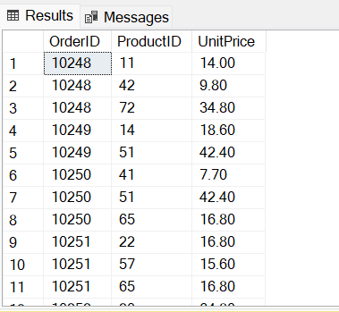

1. **Get the price of an order (by multiplying unit price by quantity).**

**Solution:**

Select UnitPrice, Quantity,UnitPrice*Quantity As Orders from [Order Details]

**Output:**

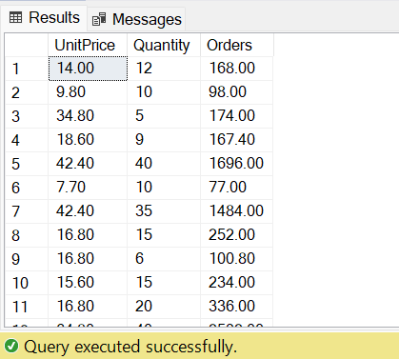

1. **Display all cities that employees belong to but don’t allow repetition.**

**Solution:**

Select DISTINCT City from Employees

**Output:**

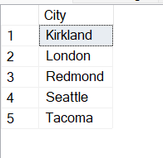

1. **Find complete name of all employees.**

**Solution:**

Select FirstName+ + LastName [Full Name] from Employees;

**Output:**

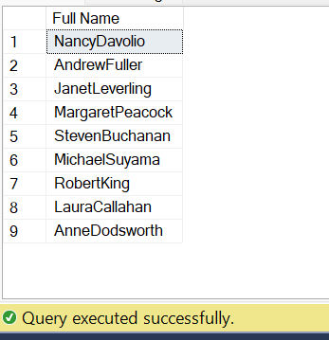

1. **Display data of all employees those working as Sales Representative.**

**Solution:**

Select * from Employees where Title = 'Sales Representative';

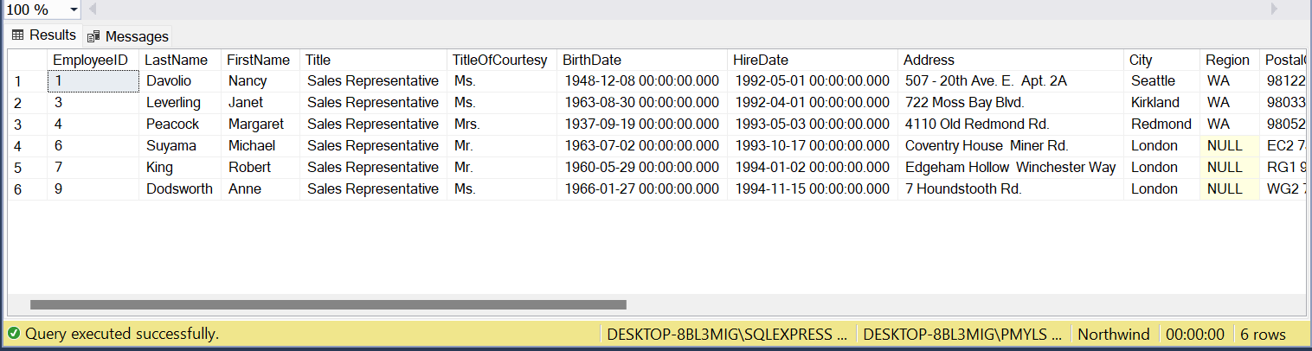**Output:**

1. **Display complete name of employees those lives in London.**

**Solution:**

Select FirstName+ +LastName [Full Name] from Employees where City in ('London');

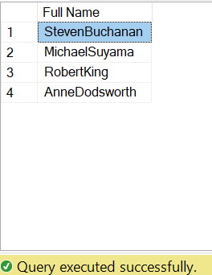**Output:**

1. **Display product name whose unit price are greater than 90$.**

**Solution:**

Select ProductName,UnitPrice From Products where UnitPrice>90;

**Output:**

1. **List the name of all employees whose first name starts with the letter ‘A’.**

**Solution:**

Select FirstName from Employees where FirstName like 'A%';

**Output:**

1. **Display names of all employees whose name contain ‘an’.**

**Solution:**

select * from Employees where FirstName Like '%an%';

**Output:**

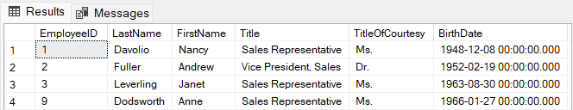

1. **Display the company name where Region is NULL in Customer Table.**

**Solution:**

Select CompanyName from Customers where Region is Null;

**Output:**

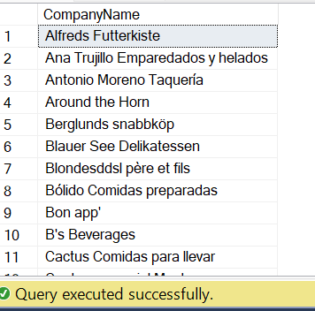

1. **Write a query to list employees who live in London, Seattle or Redmond**

**Solution:**

Select * from Employees where City in ('London','Seattle', 'Redmond');

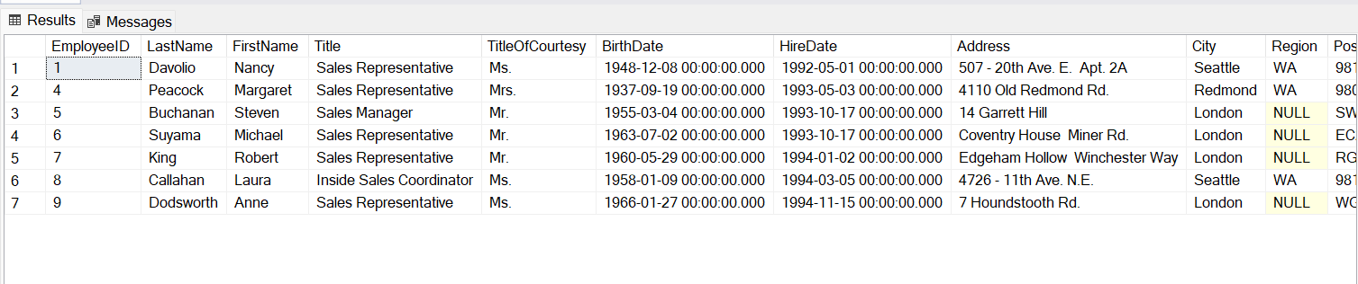**Output:**

1. **Write a query to list employees whose address contains 3 numbers in its start.**

**Solution:**

Select * from Employees where Address like '[0-9][0-9][0-9]%';

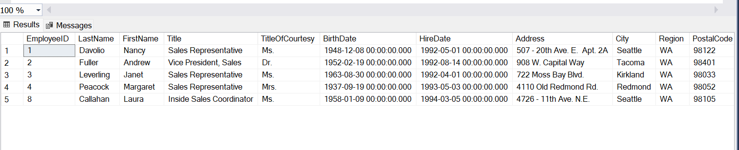**Output:**

1. **Write a query to list those employees whose TitleofCourtesy does not starts with M.**

**Solution:**

Select * From Employees where TitleOfCourtesy not like 'M%';

**Output:**

1. **List all products where UnitPrice is between 10 and 15 and QuantityPerUnit contains “bottles”.**

**Solution:**

Select ProductName,QuantityPerUnit from Products where UnitPrice between 10 and 15 and QuantityPerUnit like '%bottles%';

**Output:**

1. **List all products where UnitPrice is not in 10,12,15,17 or 19.**

**Solution:**

Select * from Products where UnitPrice not in (10,12,15,17,19);

**Output:**

